**IMPLEMENTATION SCREENSHOTS**

**YAGO**

Sampling: SRS

Confidence Interval: wilsonCC

Sampling: SRS

Confidence Interval: WALD

Sampling : TWCS

Confidence Interval: WALD

Sampling : STWCS

Confidence Interval: WALD

Sampling : SRS

Confidence Interval: WILSON

Sampling: TWCS

Sampling : STWCS

Confidence Interval: WILSON

Sampling : SRS

Confidence Interval: WILSON

Sampling : SRS

Confidence Interval: WILSONCC

Sampling : SRS

Confidence Interval: agresti-coulli

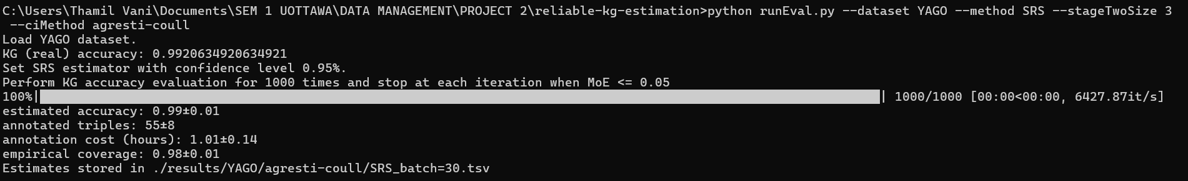

Sampling : TWCS

Confidence Interval: WILSONCC

**NELL**

Sampling : SRS

Confidence Interval: WALD

Sampling : TWCS

Confidence Interval: WALD

Sampling : SRS

Confidence Interval: AGRESTI-COULL

Sampling : STWCS

Confidence Interval: WALD

Sampling : SRS

Confidence Interval: WILSON

Sampling : TWCS

Confidence Interval: WILSON

Sampling : STWCS

Confidence Interval: WILSON

Sampling : SRS

Confidence Interval: WILSONCC

Sampling : TWCS

Confidence Interval: WILSONCC

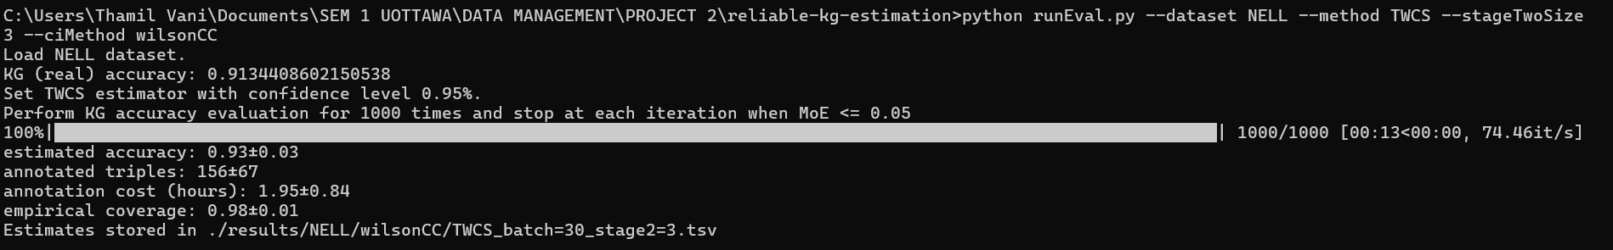

Sampling : STWCS

Confidence Interval: WILSONCC

**DISGENET TEM**

Sampling : TWCS

Confidence Interval: WISLON 0.9

Sampling : STWCS

Confidence Interval: WILSON 0.9

Sampling : STWCS

Confidence Interval: WILSON 0.5

Sampling: TWCS

Confidence Interval: WILSON 0.5

Sampling : STWCS

Confidence Interval: WILSON 0.1

Sampling : TWCS

Confidence Interval: WILSON 0.1

Sampling: TWCS

Confidence Interval: WALD 0.9

Sampling: STWCS

Confidence Interval: WALD 0.9

Sampling: TWCS

Confidence Interval: WALD 0.1

Sampling: STWCS

Confidence Interval: WALD 0.1

Sampling: SRS

Confidence Interval: WALD 0.5

Sampling: TWCS

Confidence Interval: WALD 0.5

Sampling: STWCS

Confidence Interval: WALD 0.5

Sampling: SRS

Confidence Interval: agresti-coull

Sampling: TWCS

Confidence Interval: agresti-coull

Sampling: STWCS

Confidence Interval: agresti-coulli

Sampling: SRS

Confidence Interval: WILSON

Sampling: TWCS

Sampling: STWCS

Confidence Interval: WILSON

Sampling: SRS

Confidence Interval: WALD

Sampling: SRS

Confidence Interval: agresti-coull

Sampling: SRS

Confidence Interval: WILSONCC

Sampling: SRS

Confidence Interval: WALD

Sampling: TWCS

Confidence Interval: WALD

Sampling: STWCS

Confidence Interval: WALD

**DISGENET CEM**

Sampling: SRS

Confidence Interval: WILSON

Sampling: SRS

Confidence Interval: WILSONCC

Sampling: SRS

Confidence Interval: agresti-coull

Sampling: SRS

Confidence Interval: WALD

Sampling: SRS

Confidence Interval: WALD 0.5

Sampling: TWCS

Confidence Interval: WALD 0.5

Sampling: STWCS

Confidence Interval: WALD 0.5

SYN 10M

Sampling: SRS

Confidence Interval: WILSON

Sampling: TWCS

Confidence Interval: WILSON

Sampling: STWCS

Confidence Interval: WILSON

Sampling: SRS

Confidence Interval: WALD

Sampling: TWCS

Confidence Interval: WALD

Sampling: STWCS

Confidence Interval: WALD

